Food Stress Index User Handbook
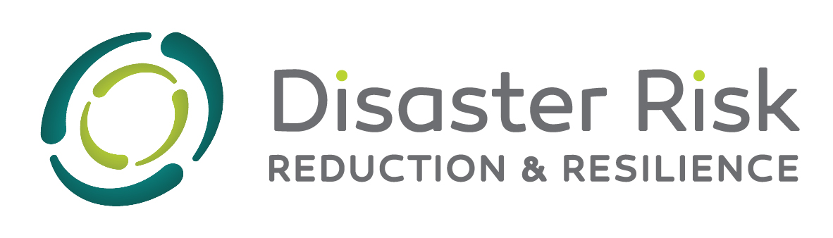
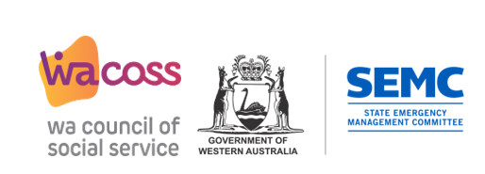

Acknowledgment
This guide was developed by the Western Australia Council of Social Service (WACOSS) and funded by the National Disaster Risk Reduction Program. WACOSS acknowledges the funding contribution made by the Commonwealth Government and support from the WA State Emergency Management Committee.

Food Stress Index User Handbook
Target audience: Charity food providers and community groups
Purpose: An easy to read guide that explains the Food Stress Index and its application.
Contents
- Background
- What is the Food Stress Index?
- How can the Food Stress Index be used?
- What information does the Food Stress Index rely on?
- Additional tools and resources

Background:
Food insecurity is defined by the WA Food Relief Framework as the “reduced or unreliable access to nutritionally appropriate or safe foods, or the reduced or unreliable ability to obtain foods in socially conventional ways. Food stress is used as an indicator of the potential of a person or household’s likeliness of experiencing food insecurity. Food Stress occurs when a person or household spends more than 25 per cent of their weekly disposable income to purchase enough nutritious food to meet their dietary needs, putting them at risk of food insecurity.
This Handbook provides organisations and government departments with an overview of the Food Stress Index (FSI) and how it can be used to coordinate appropriate amounts and types of food when responding to people who experience food insecurity. The Handbook also gives guidance to promote the use of the FSI to coordinate food in times of emergency or disaster.

What is the Food Stress Index?
The Food Stress Index (FSI) is a tool for estimating the risk of food insecurity by geographical location in Western Australia.
There are two components of the FSI that support coordination of food relief:
- Food Stress Index – The FSI geographically maps and locates food stress across the state, predicting the likelihood that a household may experience food insecurity. The FSI predicts food stress by local government area.

- Food Basket Recommendations – Information from the Food Basket Recommendations can be used by the FSI to estimate the amount of food required to provide nutritious food relief to households experiencing food insecurity.

The Food Basket Recommendations provide calculated information about the types and amounts of food needed to meet dietary recommendations for different household types, such as a couple family with children, a sole parent family, or a sole person household. Information is based on the Emergency Pantry Basket (non-perishable), which provides a guide of pantry items to meet nutritional requirements for one week only. The food items in this basket do not need refrigeration, special preparation, or cooking.

Nutritious foods including fresh fruits and vegetables, should be used to supplement the Emergency Pantry Basket as soon as possible.

How can the Food Stress Index be used?
Data from the FSI can be used to develop policy and operational interventions to improve food coordination in response to food stress. Research tells us that food insecurity increases with disaster events, and the FSI has also proven to be a valuable tool in responding to disaster-related food insecurity impacting specific geographic communities.
Using the FSI to respond to food system disruptions on service and impacted communities
- The FSI can be used to understand the level of demand for food relief in a particular geographic location in conjunction with local information (including what we hear from community members and what government data tells us), to estimate food stress and determine the geographic locations most at risk of food insecurity.

- The FSI can be used to highlight the level of food stress in each geographical area impacted and areas most at risk of high levels of food stress. During the COVID-19 pandemic service providers could predict “hot spots” and areas of high need based on the FSI.

- The FSI and Food Basket Recommendations can be used to identify the types and amounts of food that need to be sourced to make a short-term (7-day) nutritional food box for different household types and includes basic recipes and menu plans. This includes planning food boxes for people with cultural and dietary needs across a range of diverse populations.

- The FSI can also be used to map what food supplies are currently available and what needs to be externally sourced or purchased for food relief.

How will the Food Stress Index assist my organisation or community?
Recent research on how organisations have used and benefitted from the FSI found that the tool supported intersectoral collaborations that contributed to increased food security. This research confirmed that by upscaling the FSI and food baskets, we will increase the effectiveness of our efforts to prepare for and respond to disaster impacts on food security in Western Australia.
Examples
“We were cross-checking the food index tool and the map that was developed out of the tool, into our areas of need around the State. [name] is probably the largest emergency relief program in WA… we have a really good snapshot because we service around 50,000 to 55,000 clients a year… So, with the food index tool, we started to look at that and to map out our emergency relief data and our financial counselling data, and then that helped to determine our hot spots around what we thought would happen with food for our planning for this year.”

“We saw we had all the tools and predictions there, probably within the second week of April. We had everything predicted and worked out really quickly. Then it became a logistical thing because, if we were all in closedown, you didn’t have access to logistics of getting food into the State. So, then that then became the headache. The actual planning was good, and I had made a couple of large food orders before COVID broke and we went into lockdown, so we had a good chunk of food in stock pre-lockdown. And then probably five weeks into COVID, probably mid-April, same thing in that period. We managed to convince Coles and IGA and Woolworths to open up their orders to us on a larger scale….”

“… I would say most definitely the Food Stress Index continually provides a reference for myself and my organisation to go, absolutely look at this is a population or a community in high need. There’s no question around providing food or resources to that area…”

“But if we hadn’t had the Healthy Eating Basket and the experience of working in Western Australia, we wouldn’t have been able to compose on or bring the bulk supply in totality to try and get it across a weekend. And without (1) the experience of doing this and understanding it in Western Australia, and (2) without having had the Healthy Eating Basket, we would have been guessing. We would just have been trying to pool together whatever the hell we could in a short period of time and ship it out and just hope that the other components would come … [it], allowed us to response in a way that we’ve never been able to respond before. It was, in some respects, our finest hour, because we fit the job more comprehensively and to a better standard, both in terms of quality and nutrition, than we have ever been able to at any point in our history.”

What information does the Food Stress Index rely on?
The FSI combines multiple socioeconomic data sets, which are designed as a measure of overall advantage or disadvantage, with food affordability as the key determinant. Food affordability is determined by applying the food prices from the WA Food Access and Costs Survey to basic nutritious meal plans to identify the percentage of weekly household income needed to purchase a basic nutritional food basket.
The percentage of Food Affordability is then assigned to the proportion of households living with other factors associated with food insecurity, such as the household composition, number of households with Aboriginal and Torres Strait Islander residents, and household income. Together these variables create the Index.
A high food stress index does not mean that members of the household are food insecure or require food relief, it means they need to spend more than 25 per cent of their weekly disposable income to purchase food that meets a basic healthy meal plan, compared to only 14 per cent for households on an average income.

Accessing the Food Stress Index
A report has been developed which includes the latest 2021 census data and food stress index quintiles. Please refer to appendix F.
The Food Stress Index and Food Basket Pantry Items Spreadsheet prototype can currently be accessed online at the following link:
https://public.tableau.com/app/profile/tim.landrigan/viz/WAFoodStressIndex/TheFoodStressIndex
This does not currently include the 2021 census data, however efforts are being made to resource the further development of the prototype.
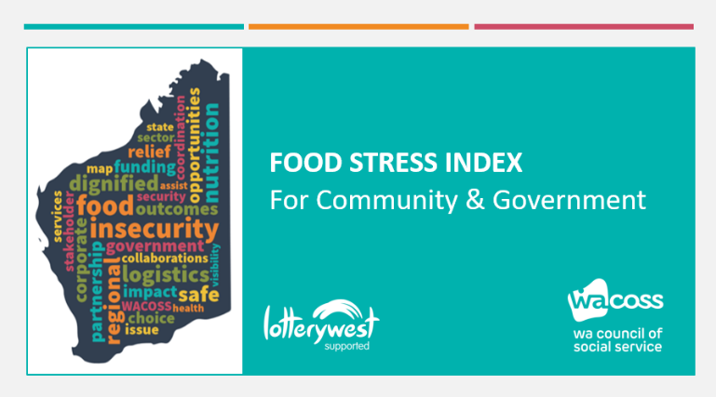

This short video tutorial is intended to accompany the handbook.
https://clipchamp.com/watch/bXzGlV4FKmk

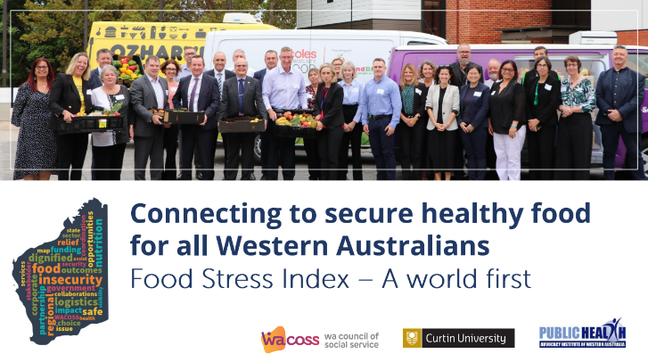

This video will provide a more detailed explanation of food insecurity. Skip to 28 minutes to hear a more detailed explanation of the Food Stress Index.
https://www.youtube.com/watch?v=vyLkVvJUA1w

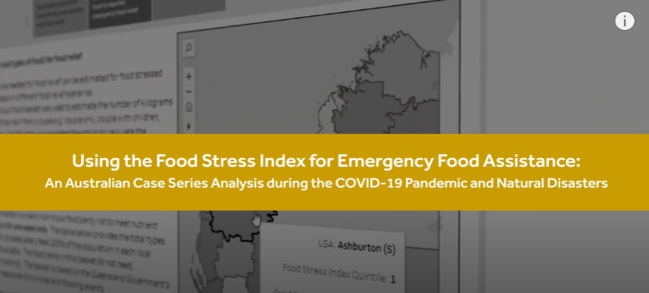

This video will demonstrate how the Food Stress Index can support organisations and governments to respond to food insecurity following a disaster impact.
https://www.youtube.com/watch?v=LM38CoEWAaM

WA Food Relief Framework. https://www.wacoss.org.au/wp-content/uploads/2019/10/Food-Relief-Framework-report-sml.pdf
Further information about this work is available in the paper: Protocol for the Development of a Food Stress Index to Identify Households Most at Risk of Food Insecurity in Western Australia - https://www.mdpi.com/1660-4601/16/1/79

