Emergency preparedness customisations on CORE and WAConnect

This document provides an overview of the platform customisations that were undertaken to support the use of Community Organised Resource Exchange (CORE) and WAConnect (WAC) for emergency preparedness.
Please note, many of these functions require the user to have allocated admin privileges in order to access the functions.

Feature one
CORE has a central resource map that geo-locates all available resources that are listed on the CORE platform. It also allows filtering of resources for emergency preparedness.
To access the resource map on CORE, use the Resource Map button the home page or on the Search page.
Admin privileges is required to view resources and filters for emergency preparedness. Admin can be allocated to people with allocated roles in recovery who can then use this function to coordinate donated resources.

Feature two
CORE and WAC user profile screens now have an option to specify capability to operate in case of crisis/disaster.
Both CORE and WAC also now have linked user profiles. Users with matching fields (ABN) will be linked across both platforms (CORE to WAC and on WAC to CORE).
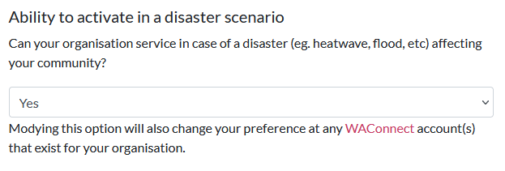
Figure 1: CORE User Profile Edit Screen

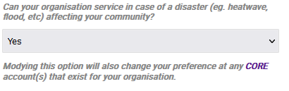
Figure 2: WAConnect User profile edit screen
When a user marks any of their organisations account(s) as Yes in the above field, all their organisational accounts across CORE and WAC will be visile in a geo-enabled search only when logged in using an admin account.
For CORE this is accessed on the Resource Map screen. For WAC, this is accessed via the normal search (just above the filter/Kms button)
On CORE and WAC, this will show the listings/outlets that are available from users who have marked Yes in that field.
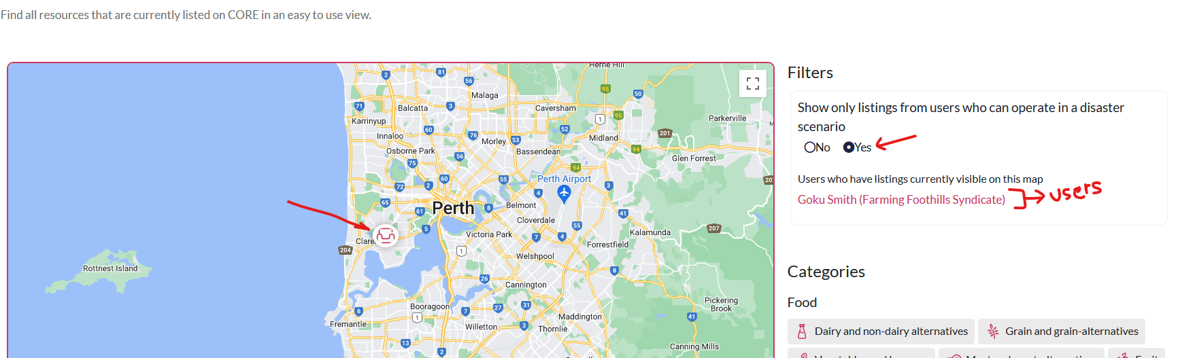
Figure 3: How to view the disaster activation enabled listings in CORE

To send a disaster notification email to users with disaster capability on CORE:

- Click on the user’s name as shown in Figure 3,
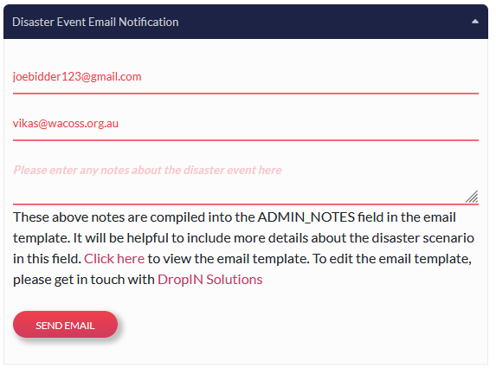
- Scroll down to the Disaster Event Email Notification field,
- Enter any specific notes about the disaster event, and press Send.

To send a disaster notification email to any of these users on WAC:

- Search for the service you would like to find,
- Enable the toggle to show outlets from users who have marked activation in a disaster and press Filter Results
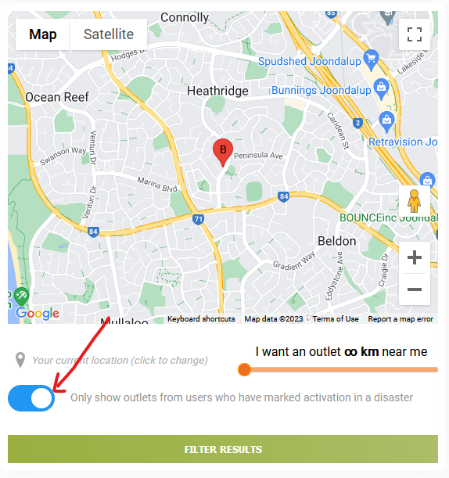
- Click on the user you wish to send the email notification to.
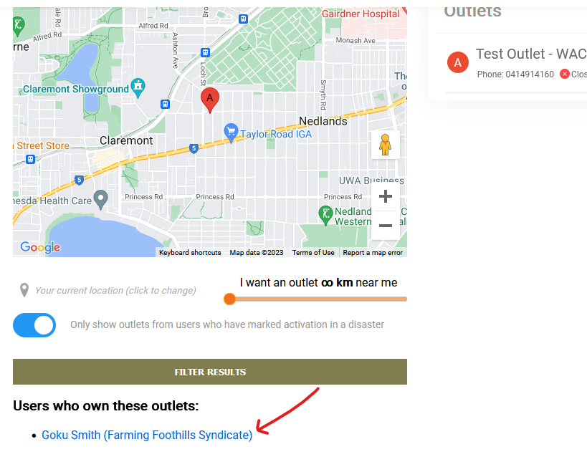

- Enter your notes about the disaster event, and press Send.
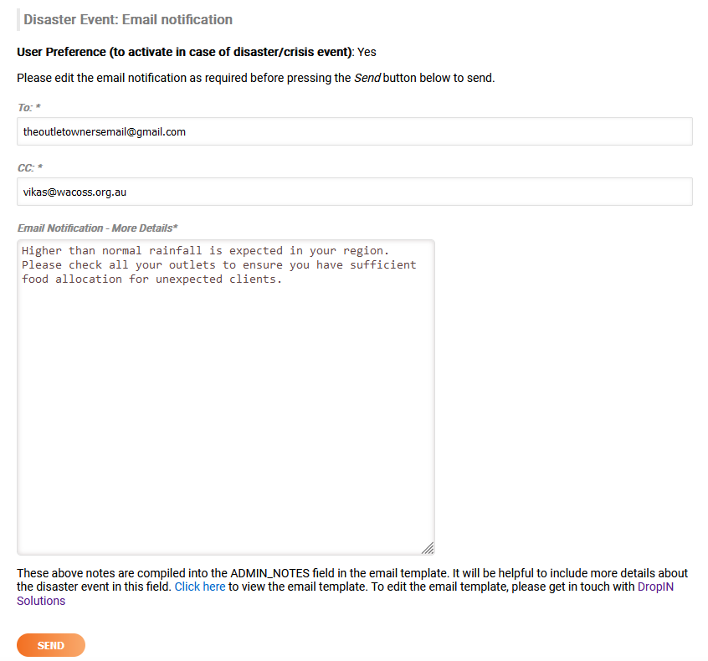
The email template used both on WAC and CORE can be individually changed. To view the current template (that is collated with disaster noted submitted, click here.

