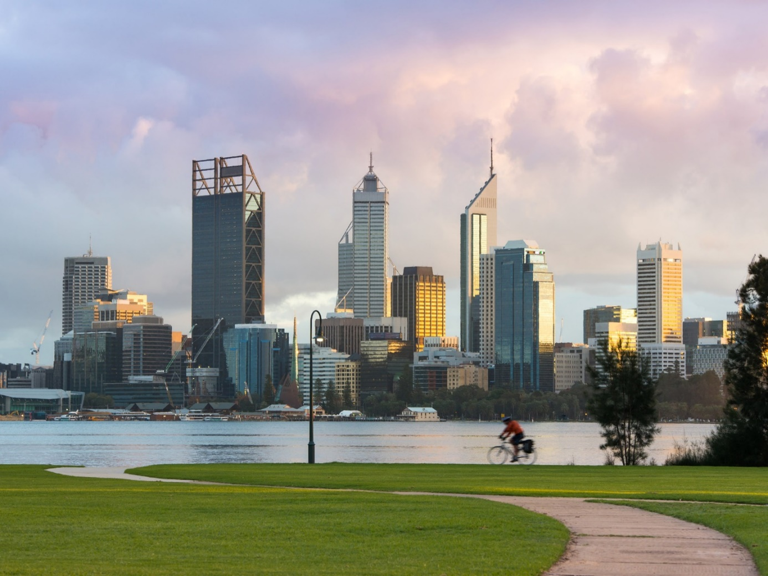er

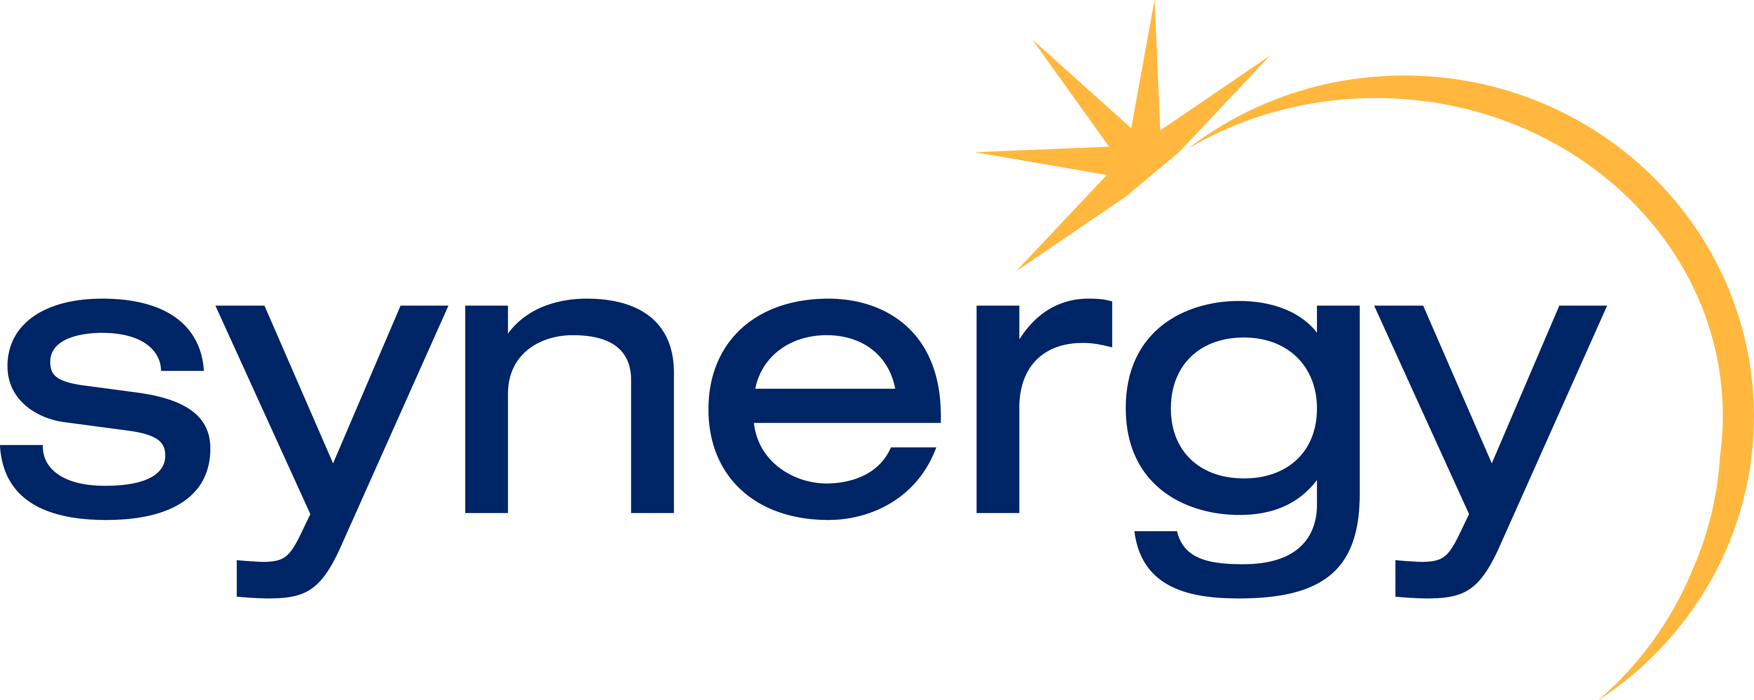

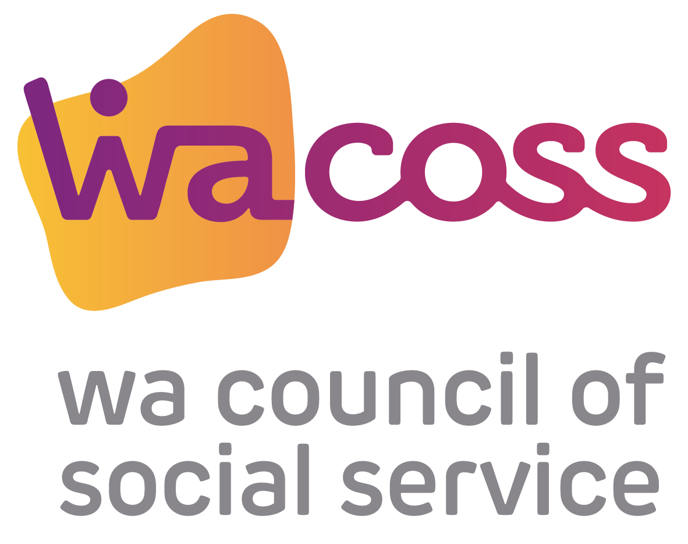

**July 2022 to Jun 2023**

**Synergy Power Assist Scheme Application**

**Has the customer applied for assistance through Synergy?**

When applying for a Power Assist grant always check if the customer is also being assisted through Synergy Credit Management. If the Synergy customer has a very large account and/or appears to be in serious financial difficulties you should also consider referring them to a Financial Counsellor, if possible.

C:\Users\leela\AppData\Local\Microsoft\Windows\INetCache\Content.Outlook\10HT71J0\Logo.jpg

C:\Users\leela\AppData\Local\Microsoft\Windows\INetCache\Content.Outlook\10HT71J0\Logo.jpg

**Power Assist Funds Available Yes/No Assistance Granted Yes/No**

**Comment** (if applicable)

**\*Please note that the applicant may still receive an automatic reminder notice up to 10 days after the approval for assistance**

(Account must be over $100 be eligible for assistance)

**Synergy Power Assist Application Form**

**Fax or Email**

**To: St Vincent de Paul Society – Power Assist**

**Fax: (08) 6323 7523 or** [**Email: powerassist@svdpwa.org.au**](mailto:powerassist@svdpwa.org.au)

**(Faxing – do not attach a cover page. Emailing – please scan the account.)**

Before you fax please ensure you have completed all sections of this form and have attached a copy of the Applicant’s Electricity Account. **If any part of the form is incomplete, it will be rejected.**

**Applicant Details**

Full Name:

Partner’s Name:

Address:

Postcode:

No of Children:

Account Number:

**Please indicate (for caption data):**

E.S.B

A.T.S.I.

C.A.L.D.

Unknown

*Refer to ‘Useful Information’ section at the end of this form for explanation of the above acronyms

**Total of Applicants Bill**

**$**

**Payment Request** Power Assist Grant: Up to but not exceeding $200

Other Contributions if Applicable (please state contribution source and amount contributed):

HUGS: Your agency contribution: Other:

**Please rank application Priority** (this is required in the event applications outnumber funding available):

1.

2.

3.

4.

5.

6.

**From**

Agency Name: Town/Location:

Fax No: Phone No:

Authorised by (Please print name)

Signature Date

**Authority to exchange information on my behalf**

I (applicant) authorise

(name of Agency Representative) to exchange information on my behalf with Synergy and SVDP regarding my application for assistance with payment of my Electricity account.

Applicant’s signature Date

Date

**Referring Agency will be notified of the outcome by return fax within 7 working days after the funding round.**

**Power Assist Allocation Dates 2022/23**

**2022**

18/19 July

18/19 Aug

12/13 Sep

17/18 Oct

14/15 Nov

08/09 Dec

**2023**

12/13 Jan

13/14 Feb

16/17 Mar

20/21 Apr

15/16 May

08/09 Jun

**\*Please note: Forms received outside of these dates will not be processed.**

C:\Users\leela\AppData\Local\Microsoft\Windows\INetCache\Content.Outlook\10HT71J0\Logo.jpg



**This is YOUR checklist – Please DO NOT send this page**

**Easy Application Instruction**

Step 1 - Complete the eligibility checklist below

Step 2 - Complete the application form

Step 3 - Include a copy of the Applicant’s Electricity account with the application

Step 4 - Fax or Email the completed applications to SVDP (08) 6323 7510 on the specified allocation dates (No cover

sheet please)

This scheme is funded by Synergy and administered by SVDP on behalf of the CRR sector.

For further information, please contact **WACOSS** on **(08) 9420 7222**

Country free call: **1300 658 816**, SVDP on **(08) 6323 7523** or visit [**https://dropin.org.au/display/CoRR/News+and+Updates**](https://dropin.org.au/display/CoRR/News+and+Updates)

**Eligibility Checklist**

All boxes must be checked for consideration to receive assistance under this scheme Our agency confirms the Applicant is experiencing financial hardship

Our agency is an Emergency Relief Agency/Outlet providing some of the following services - assist clients to obtain food, household essentials and/or help with bills and/or

Financial Counseling Service

The Applicant has not previously received funds under this scheme during this financial year (July 2022 to June 2023).

A payment plan has been made with Synergy for payment of the remainder of the account (this is only required in the case of large bills, overdue accounts or customers close to disconnection).

**Before you fax or email the application form please confirm**

All details are completed on the application form by the Agency Representative

The application states a priority listing must be made of the applications submitted for that round The applicant has signed the ‘Authority to Exchange Information’ section of the form

You have included a copy of the applicant’s electricity account

You have informed your client that this is an application for assistance only and that they must contact your agency in relation to an acceptance or rejection of their application

**Useful information**

1.

2.

Applications that do not meet the eligibility criteria may be rejected.

There are limited funds available for each allocation period. Confirmation of acceptance or rejection will be sent to your agency by return fax/email within 7 working days after the funding round.

Agencies without fax or email facilities can post applications to SVDP, PO Box 1450, Canning Vale DC, WA, 6970.

SVDP checks all applications to confirm whether assistance has been provided under this scheme during this financial year i.e. 2022/23.

Please note that ethnicity details must be completed for data collection purposes

E.S.B. = English Speaking Background, A.T.S.I. = Aboriginal &/or Torres Strait Islander,

C.A.L.D. = Culturally & Linguistically Diverse.

3.

4.

5.