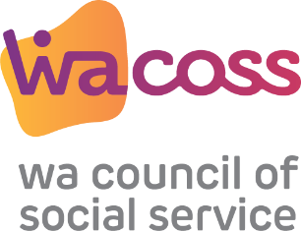
Community Relief and Resilience – consumer checklist resilience – consumer checklist
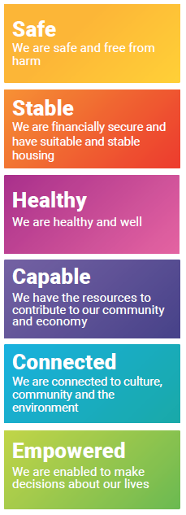 | Feeling secure, protected and living a life free from harm has long been recognised as one of the most basic human needs  - Is the person subject to personal or family violence, and/or physical or emotional neglect?  - Is there a risk of self-inflicted injuries or suicide?  - Is there a dependent, such as a child, who may be unsafe?
A sufficient income, along with safe and secure shelter, is essential
for a person to be able to fully engage in their community

- What is the person’s main source of income?
- Is that income adequate to cover weekly living expenses?
- Does the person have outstanding debts?
- Is the person’s accommodation safe and secure?
Health is impacted by a range of social, economic, cultural, and environmental factors, such as poverty. Good health is crucial to overall wellbeing and resilience

- Does the person have any health or mental health problems?
- Does the person have a disability that creates barriers for
them?
Education and training are essential to equip us with the knowledge and skills we all need to contribute to and benefit from our community and economy

- Is the person currently engaged in education or training?
- Does the person have the support to gain employment?

Individual and community connections are critical for social and emotional wellbeing

- Does the person have a supportive family?
- Is the person linked through a local social network?
- Does the person have a strong connection to culture?

People have a fundamental right to make decisions about their own
lives, because they know what is in their best interests
- Are the person’s rights and choices being acknowledged and respected?
- Does the person require assistance in managing and addressing their needs?

Community relief & resilience – consumer outcomes
Community Relief and Resilience – consumer outcomes checklistresilience – consumer checklist
Immediate outputs/outcomes
- Person has a plan in place to ensure own or others safety
- Reduced exposure to violence or abuse
Intermediate outputs/outcomes
- Reduced incidence of FDV / child protection system
- Families have relationships safe from harm
Immediate outputs/outcomes

- Person has immediate financial crisis needs met
- Person has access to nutritious food and accommodation
Intermediate outputs/outcomes
- Improved financial resilience
- Stabilised housing
Immediate outputs/outcomes

- Early identification of health issues and link to supports
- Establishment of referral pathways to relevant services
Intermediate outputs/outcomes
- Reduced admissions to secondary and tertiary health services
Immediate outputs/outcomes
- Person can identify skills and learning required to achieve their goals and a pathway to acquiring these
Intermediate outputs/outcomes
- Person actively engaged in education / training
- Improved rates of local school attendance

Immediate outputs/outcomes
- Person aware of and accessing community programs / activities
- Person is supported to connect with family / culture etc
Intermediate outputs/outcomes
- Stronger sense of community belonging
Immediate outputs/outcomes
- Person can articulate needs and advocate for services
- Person linked to advocacy and community legal centres
Intermediate outputs/outcomes
- Community and family wellbeing enhanced
- Reduced need for community relief and resilience services

Community relief & resilience – consumer referrals

Community Relief and Resilience – consumer referrals resilience – consumer checklist
Local supports that can help
- Crisis care
- Domestic violence services
- Women’s health centres / men’s help lines
- Mental health supports
- Department of Communities
Local supports that can help

- Entry point / Housing providers
- Tenancy support services
- Employment support services
- Financial counsellors / financial capability officers
- National Debt Helpline
Local supports that can help

- Bulk billing GP’s / Street doctor
- Local counselling services
- Mental health programs
- Sport and recreational activities
Local supports that can help

- Parenting and family support services
- Employment support services
- Education / training providers
- Local schools

Local supports that can help

- Peer supports
- Connect groups
- Volunteer organisations
- Sport and recreational activities
Local supports that can help
- Peak bodies
- Advocacy and community legal centres
- Local government

Community relief & resilience – consumer notes

Community Relief and Resilience – consumer noteschecklist

Strengths

Issues

Plans

Strengths

Issues

Plans

Strengths

Issues

Plans
Strengths

Issues

Plans
Strengths

Issues

Plans

Strengths

Issues

Plans

