Red Zone – COVID-19 positive clients
This Photo by Unknown Author is licensed under CC BY-SA

All PPE must be used when entering this area
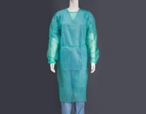 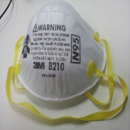 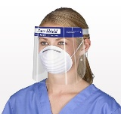 OR 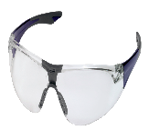 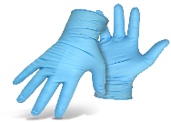
This Photo by Unknown Author is licensed under CC BY
This Photo by Unknown Author is licensed under CC BY-SA
This Photo by Unknown Author is licensed under CC BY
This Photo by Unknown Author is licensed under CC BY-NC
This Photo by Unknown Author is licensed under CC BY-NC

Gown N95 Face Shield Goggles Gloves
Red Zone Areas include:
The Room/ bedroom of the Client who is positive for COVID -19
The shared bathroom while the COVID positive client is using the bathroom. Please note the client would go last when showering, after the room has been used and cleaned it must be and left to dry before being used by another client.

