Green Zone – no known Coronavirus

Surgical Mask must be worn at all times except when eating or drinking in this area

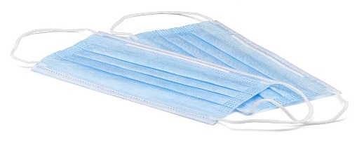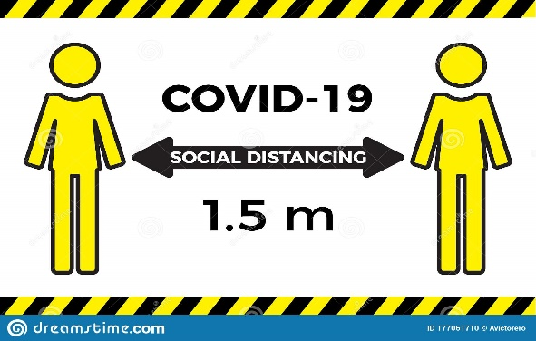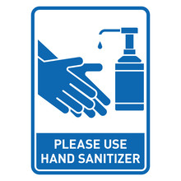
This Photo by Unknown Author is licensed under CC BY-SA
Surgical Mask Social Distance Hand Sanitise

Areas that are classes as Green Zone:
Kitchen
Lounge room
Dining room
Outdoor garden areas

