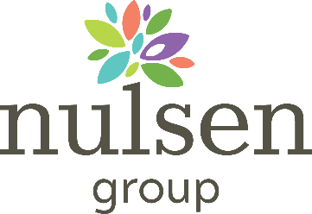

ATTENTION ALL VISITORS!

The house is not accepting any visitors at this point in time. Please contact the house to discuss any urgent matters or resident care.

Thank you for your understanding.
We look forward to seeing you soon.

Please place this sign on the front door of the home in a place that is visible to all guests.

