Purpose

This procedure has been developed to guide the delivery of Rapid Antigen Test (RAT) screening for COVID-19 in community service settings for Anglicare WA (AWA) to protect workers, their families, clients and the community.

Rapid Antigen Testing, in combination with a mandatory vaccination program and other COVID safeguards, forms part of the Anglicare WA safety system to assist the organisation to meet its work health and safety obligations and to minimise the risk of impacts caused by a COVID outbreak at our workplaces.

Vaccinated workers must still take part in workplace screening, as it is still possible for vaccinated individuals to contract COVID-19 and pass it on. COVID-19 vaccines are safe and effective and can significantly reduce spreading the virus to others.

Anglicare WA (AWA) workers conducting RAT screening must adhere to this procedure and WA Department of Health guidelines. Only RAT kits approved by the Therapeutic Goods Administration (TGA) must be used and all test results to the AWA COVID-19 Response Manager must be reported.

Suitability

RATs are a convenient screening tool to detect COVID virus fragments in nasal secretions or saliva. They are designed to be self-administered and give an answer in minutes. Detecting infection early is critical to preventing spread and allowing persons at risk of severe disease to get timely access to close monitoring and new life-saving therapies.

If a person has flu-like symptoms or symptoms associated with COVID-19, Rapid Antigen Testing should not be used. The person should immediately get tested at a designated COVID testing clinic. The location of testing sites across WA can be found on the WA Department of Health website.

Get tested if you have any of the following symptoms, no matter how mild:
- Fever or a recent history of fever (e.g.: night sweats or chills) without a known source
- Cold or flu-like symptoms (including cough, shortness of breath, sore throat, runny nose)
- Loss of smell or taste

Eligibility

Rapid Antigen Testing should only be used for people who do not have any symptoms (asymptomatic).

At Anglicare WA, RATs will be prioritised for the following work groups in the following situations:

- Workers that have face to face contact with colleagues or clients in vulnerable settings as part of their work role in AWA Response Phases Yellow and Red.
- Workers that are required to travel outside of their regional area in phases Blue, Yellow, and Red.
- As a risk mitigation tool authorised by the AWA COVID-19 Response Manager.

Communication

All RAT results from workplace screening must be reported by completing the AWA online reporting form with their contact details and the result. This will be used to inform the level of self-testing and outcome as part of the surveillance testing.

Privacy

Anglicare WA respects the privacy of each worker, and their consent is required for their RAT results to be accessed by the organisation. Workers utilising RATs provided by AWA, give implied consent for AWA to review and store this data.

Anglicare WA is compliant with Australian Privacy Law including the Privacy Act. All information and data will be maintained in accordance with the Anglicare WA Privacy Policy which can be found at www.anglicarewa.org.au/privacy .

Data and statistics of RATs across the organisation will be published with Personal Identifiable Information (PII) removed. This data reporting is for:

- Occupational safety and health purposes
- Assessing and monitoring the organisations COVID resources and response
- Any other reason deemed appropriate by a Director or the CEO

Safety and Health Requirements

Rapid Antigen Tests quickly detect proteins from the virus that causes COVID-19. Early identification helps to reduce the spread of COVID-19 in the workplace and the community.
However, the use of RAT’s gives rise to a number of issues that must be considered, including those that relate to the efficacy of the testing method, practicalities and cost of testing a large workforce and in relation to any workers that are unwilling to undergo this type of testing. This includes:

- A limitation of RATs is that it is less sensitive than current PCR diagnostic testing procedures used by COVID clinics, with the result that it may likely miss a greater number of COVID-19 cases than standard testing procedures.

- AWA anticipate that we will be responsible for procuring our own test kits (either directly or through a third-party RAT service), in line with the TGA requirements, and will bear the costs of implementing RATs. Though government assistance in the supply of these resources is welcome, we cannot rely on this alone.

- RATs present potential logistical challenges for AWA, as our organisation has multiple office locations across the State. Based on this, supply of RATs may be distributed to regional hubs.

Provision of safe and high-quality rapid antigen test screening requires that:

- The testing environment is fit for purpose. All equipment is in good working order, all procedures are carried out accurately, efficiently and safely and the wellbeing and confidentiality of the individual is respected, especially in relation to test result.

- The Procedure set out below for rapid antigen screening at AWA is adopted by sites providing using the RATs.

7.0 Issuing RAT kits

Local area managers will be issued RAT kits for their region. These managers may issue a number of these kits directly to staff, with no more than 6 kits being issued to any one person.

RATs supplied by Anglicare WA must only be used for work purposes, and must not be given to family members, friends, or other staff.

Managers issuing kits should keep records of which staff have been issued kits. A sample register form is available in appendix three

Procedure

Designated workers will be notified at the times when RATs need to be undertaken. The timing and frequency of testing will be highly dependent on the current response phase as well as contextual risk of the worker’s activity.

Because of the rapidly changing COVID-19 environment current testing requirements may change at short notice. Workers and managers must regularly refer to testing requirements which are published on the AWA COVID-19 communication site.

7.1 Frequency and Timing

As an initial indication, RAT will take place for each worker no more than twice weekly, at least two days between test. In instances where workers are only carrying work with risk of exposure once a week, a single weekly test is all that is required.

Workers will undertake the test at the commencement of the working week at least 3 days after the preceding RAT. The worker must undertake the RAT prior to commencing work. In cases where workers have been issued kits to use from their home, this should take place in their home prior to travelling to the work location.

Prior to any testing, workers must read and fully understand the RAT kit instructions.

Follow the kit instructions for use. Instructions may vary between RAT manufacturers, so it is important to read instructions carefully each time.

If a worker is unsure or needs support with the process, they should contact the COVID-19 Response Manager before attempting to carry out the test, to avoid invalid results and the subsequent waste of a test kit.

A designated area away from other people should be used. This may be a designated space in the workplace or in the worker’s home that has:

- A stable and clean surface where the test kit can be laid out. It is important that the space is cleaned and dried directly before the test.
- Hand hygiene supplies (either hand sanitiser or hand washing facilities)
- Disinfectant cleaning supplies (isopropyl wipes or similar)
- Means of remote communication (mobile phone) in case of positive test result
- Some type of timer (mobile phone application or other) for checking test results

For testing at worksites –

- P2/N95 mask for the worker
- a designated route that can be used by the test subject in the event of a positive test result. This route should be (or can be made to be) clear of all other people as far is as reasonably practicable.

The testing steps should follow the flow chart below:

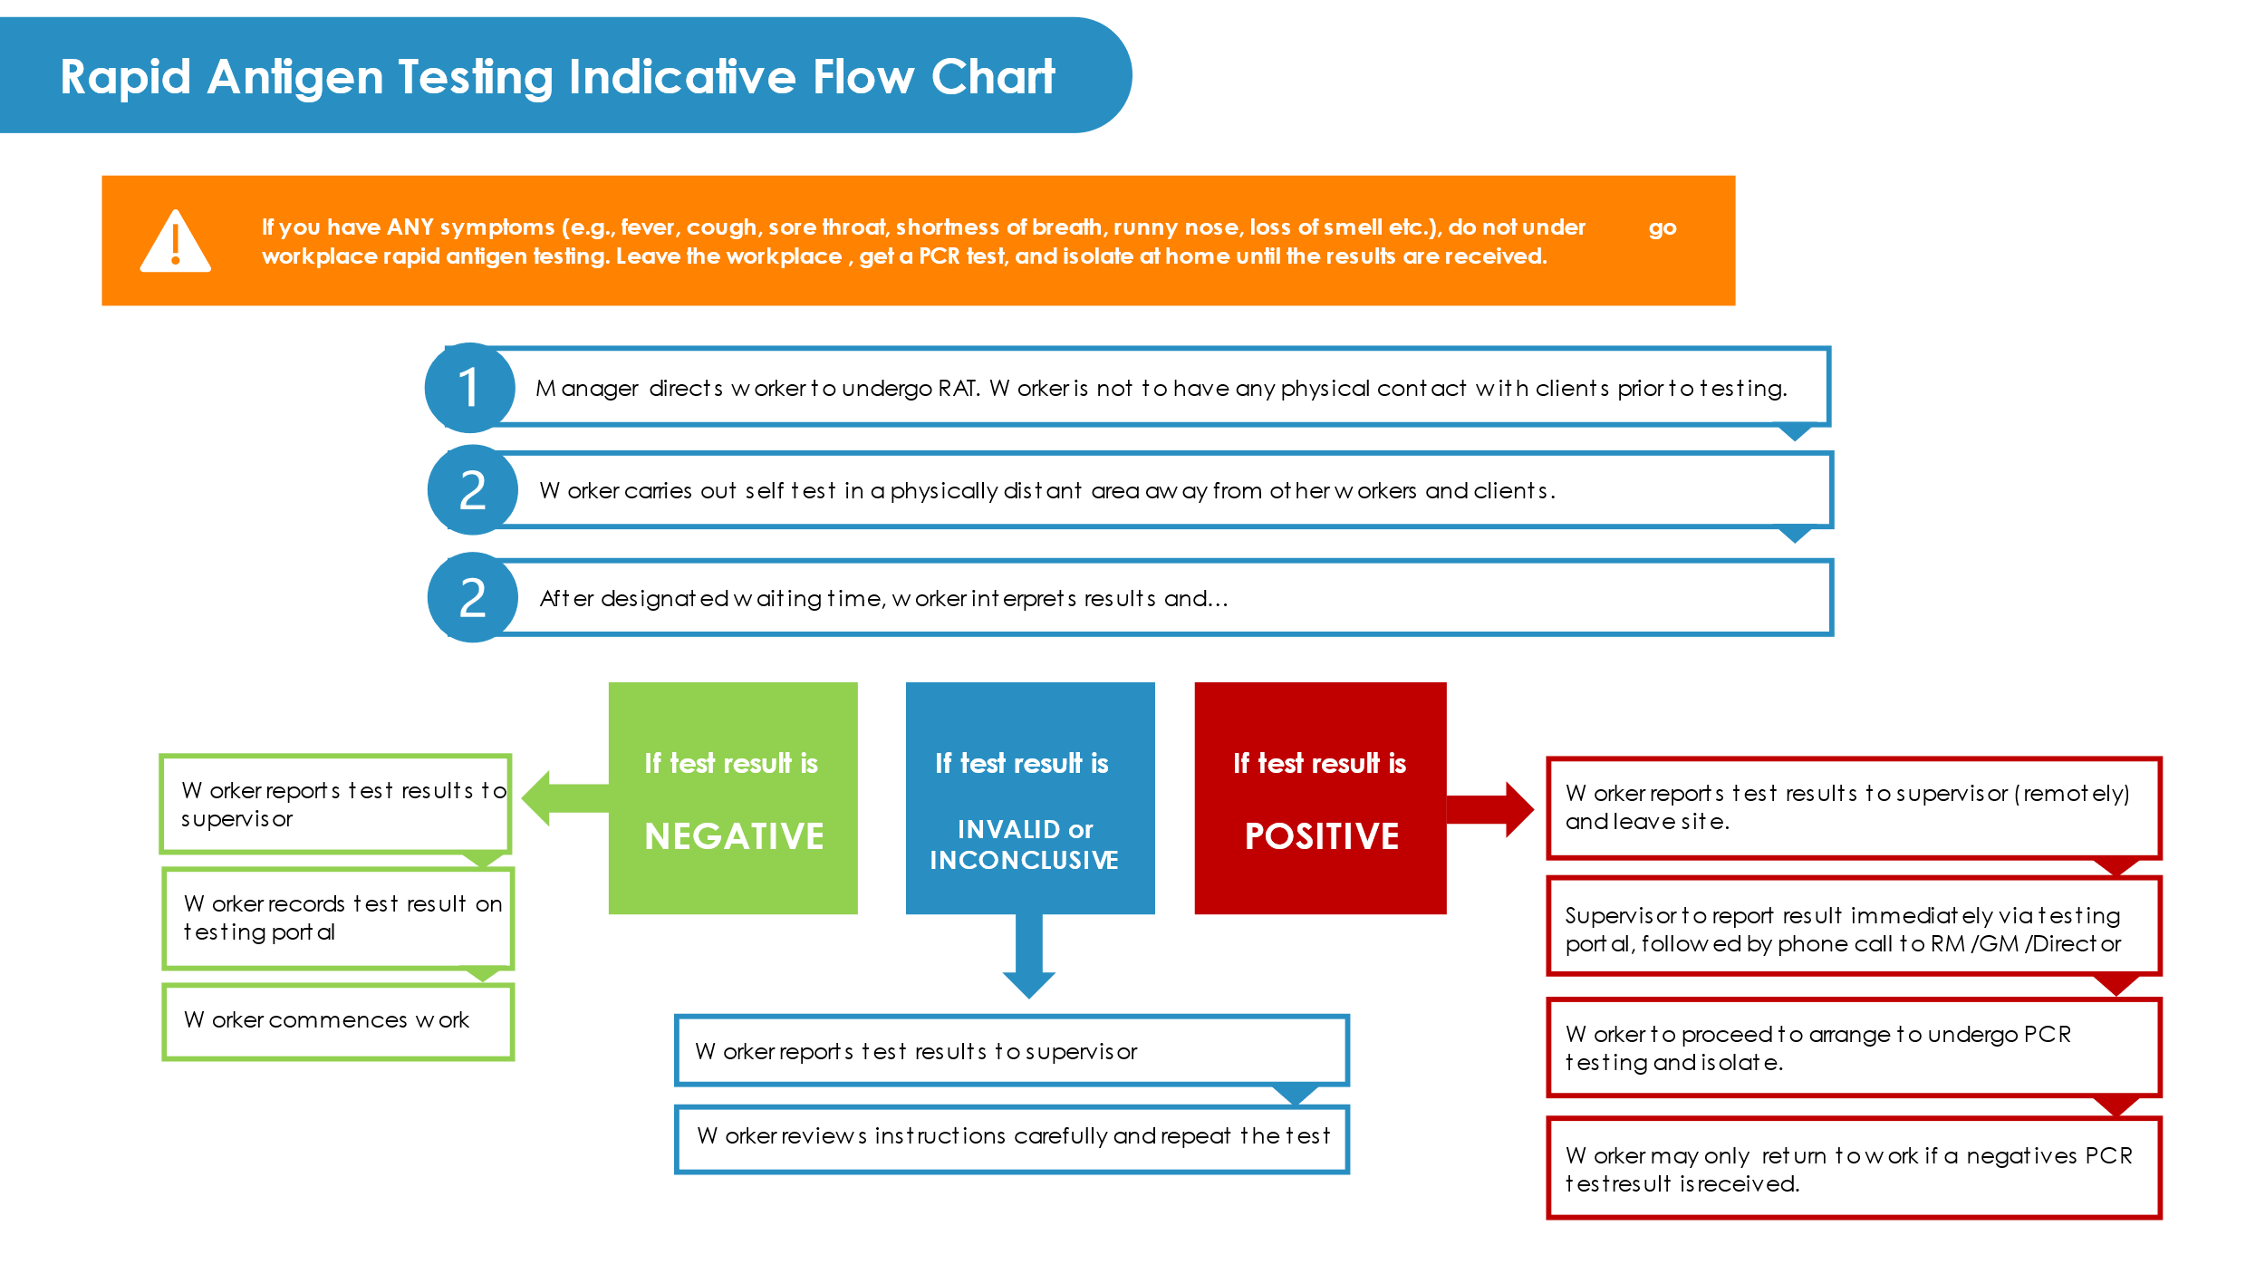

Managing the test results

Positive Results
In line with the Rapid Antigen Testing Indicative Process, a person who receives a positive RAT result must confirm this result by immediately leaving the site via designated travel path and travel to the nearest COVID-19 testing clinic for a standard PCR test. The worker must undertake a PCR test and follow any WA Department of Health advice before they can safely return to the worksite. It is important that workers know how to find their closest testing clinic. They must isolate until a negative PCR result is returned. This result should also be reported to AWA via the online reporting form.

Negative Results
In line with the Rapid Antigen Testing Indicative Process, where a person receives a negative result, they must report this using the online reporting form; the person can then proceed to their work site.

NOTE: RATs are not 100% accurate (most tests have a sensitivity of around 80%). A persons should never assume that a negative RAT means that they are definitely COVID-19-free.

Invalid or Inconclusive Results
In line with the Rapid Antigen Testing Indicative Process, where a person receives an invalid or inconclusive result, they must report this using the online reporting form and repeat the test a second time.

Reporting of Data
All rapid RAT results from workplace screening must be reported by everyone who uses a rapid antigen test via the online reporting form, including the submission of their contact details and the result. This will be used to inform the level of self-testing and outcome as part of the surveillance testing.

Individuals who report a positive rapid antigen test result as part of workplace screening may be followed up by AWA to confirm they have been retested at a designated COVID clinic following their positive RAT result.

Managing the kit stockpiles and supplies

Overall management of the RAT kit stockpile will be overseen by the AWA COVID Response group. RAT kits will be carefully distributed across the organisation and held at strategic locations (based on service delivery estimates). Local COVID Response teams will be responsible for the secure storage and issuing of the test kits in accordance with the direction from the AWA COVID Response Manager.

Every kit that is issued out must be recorded on a local register. Site registers are accessible via the intranet, here.

Roles and Responsibilities

Role | Responsibilities
Workers | - Read this procedure prior to participating in workplace RAT.  - Read and understand the RAT instructions for use.  - Only use the test as instructed and with manager approval.  - Report test results immediately and accurately via the AWA reporting form
Supervisor/Manager | - Store and maintain the RAT kits supplies for their local workplace and maintain the supply register.  - Record the issuing of RAT kits to workers (via the RAT testing form).  - Maintain information privacy in accordance with the AWA Privacy Policy.
AWA COVID-19 Response Manager | - Record and report RAT results data.  - Support workers with guidance of how and when to use RAT.  - Maintain organisation wide RAT kit resources register

RECORDS MANAGEMENT
The following information is maintained as a result of this process:
Record | Details/Location
Test Results | - COVID Response Manager
Site RAT Registers | - Intranet

APPENDICES

Appendix | Title
1. | Fact Sheet: COVID-19 Rapid Antigen Testing and Screening - Information for workers

Appendix 1:

Fact Sheet: COVID-19 Rapid Antigen Testing and Screening - Information for workers

Why is rapid antigen testing is being implemented in our workplaces?

Anglicare WA has implemented a regular workplace screening initiative to protect you, your family, your colleagues, clients and the community.

Screening workers at least twice a week can help to quickly identify and isolate those who have COVID19, especially as those undertaking rapid antigen testing are those who don’t have any symptoms and would not otherwise be undertaking COVID-19 testing.

Early identification helps to reduce the spread of COVID-19 in your workplace and in your community. Rapid antigen tests detect proteins from the virus that causes COVID-19. They’re quick and easy to use. Results are provided in 15 to 20 minutes.

If you’ve been vaccinated, you should still take part in your workplace screening initiative as it is still possible for vaccinated individuals to contract COVID-19 and pass it on. The vaccines are safe and effective and can significantly reduce your chance of spreading the virus to those around you.

How is rapid antigen testing different to other testing?
There are two kinds of tests: diagnostic and screening tests. Rapid antigen tests are a screening test that are used to potentially identify positive cases earlier to help reduce the spread of the virus and prevent and manage outbreaks.

When used regularly, rapid antigen tests may help identify individuals who may be infectious early on. Individuals can be pre-symptomatic or asymptomatic but still carry the virus and may transmit it to others.

A standard test such as polymerase chain reaction (PCR) tests, is a diagnostic test, and can confirm if someone has COVID-19, with results available in 24 to 48 hours.
These tests take a deep nasal sample and throat sample and are tested in laboratories.
A positive rapid antigen test doesn’t mean you necessarily have COVID-19, it means you need to get a standard (PCR) test straight away.

What is the accuracy rate of Rapid Antigen Tests?

Rapid antigen tests will detect most cases of COVID-19, but they are not sensitive enough to be a ‘rule out’ test as they may miss some cases of COVID-19.
A negative test does not completely exclude COVID- 19, and you should have a PCR test if you develop symptoms or are identified as a close or casual contact of someone who has COVID-19. This is even if you have recently returned a negative rapid antigen test.
What if I get a positive test result?

If you get a positive rapid antigen test result, you must immediately get a standard test (called a PCR test) at a WA COVID-19 testing site to confirm the result of your screening test.
Rapid antigen tests will detect most cases of COVID-19 but are not as accurate as a PCR test.
Isolate until you receive notification of your result. Isolating immediately can help break chains of transmission and limit the spread of COVID-19 at your workplace.

You are requested to report all positive and negative rapid antigen test results to Anglicare WA.

What if I get a negative test result?

Continue to follow the latest health advice and restrictions in your area. If you develop any symptoms, even if mild, you must immediately get a standard COVID-19 test (PCR test) and isolate until you get a negative result from WA Health.

What if I have symptoms of COVID-19?

Do not undertake a rapid antigen test and do not attend the work site. You must immediately get a standard COVID-19 (PCR) test at any COVID-19 testing clinic in WA, isolate, and follow the advice given by WA Health. The only way to rule out COVID-19 is to have a PCR test, even if you have only mild symptoms.

Is personal data collected?

Any testing data collected will only be used to help Anglicare WA make WHS decisions. None of your personal health data is used without your consent.

Anglicare WA RAT Results Reporting Form

Appendix 2:

COVID-19 RAT Scenario Examples

Scenario One

John is a Case Manager at Foyer Oxford, working full-time, but in the Yellow and Red zone the team have adopted an A/B roster.

John is in the office this week, so he uses a RAT on Monday and Wednesday morning before he comes to work. He uses the RAT recording form to submit the result and texts a photograph of the result to his line manager Yanthe, who confirms the result.

John is working from home next week and is not going to have any face-to-face contact with clients, so he doesn’t need to use a RAT until he is next in the office.

Scenario Two

Maree is a Residential Youth Worker at YSHAC, and his shifts this week are Monday and Tuesday overnight, and Saturday and Sunday afternoon.

Maree will use a RAT on Monday morning, submit the recording form and text a photograph of the result to Daniel, their line manager. The test result is negative, he attends work on Monday and Tuesday.

Maree then uses another RAT on Saturday morning, submits the recording form and texts the result to Daniel. Hooray, it’s negative. Maree attends work on Saturday and Sunday.

Scenario Three

Rodney is a CCS worker in Albany. He works two shifts a week; one on Saturday and one on Sunday.

Rodney will carry out a RAT on Saturday morning and complete the RAT recording form and report the results to his line manager. Rodney does not need to carry out another text the next day on Sunday.

Scenario Four

Kim works at an op shop in the Perth Metro area and recently received her second vaccination. She does not have COVID symptoms and has no known contacts.

She is scheduled to work Monday morning, so takes a RAT and returns a positive test. What does this mean?

In this instance, Kim should report the result to her manager and via the results reporting form immediately. From there Kim should confirm the result by getting a PCR test. She should follow Department of Health guidance and isolate.

Appendix 3: RAT kits issue register

Full Name | Date issued | Number of RAT issued | Signature of recipient

