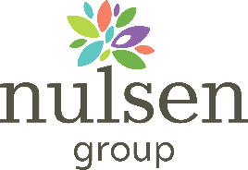

Cleaning
Use the following steps to clean an environment:
1. Wear gloves when cleaning.
- Gloves should be discarded after each clean.
- If it is necessary to use reusable gloves, gloves should only be used for COVID-19 related cleaning and should not be used for other purposes or shared between workers.
- Wash reusable gloves with detergent and water after use and leave to dry.
- Clean hands immediately after removing gloves using soap and water or hand sanitiser.
2. Thoroughly clean surfaces using Chlor Clean.
- Always clean from the cleanest surfaces to the dirtiest surfaces.
- This stops the transfer of germs to cleaner surfaces and allows you to physically remove and dispose of the largest possible amount of germs.
3. Covid Station must be cleaned daily – remove all stock and wipe down trolley before re stocking trolley.
4. Clients room must be cleaned daily.

Place this sign on the side of the trolley with list facing to the outside

