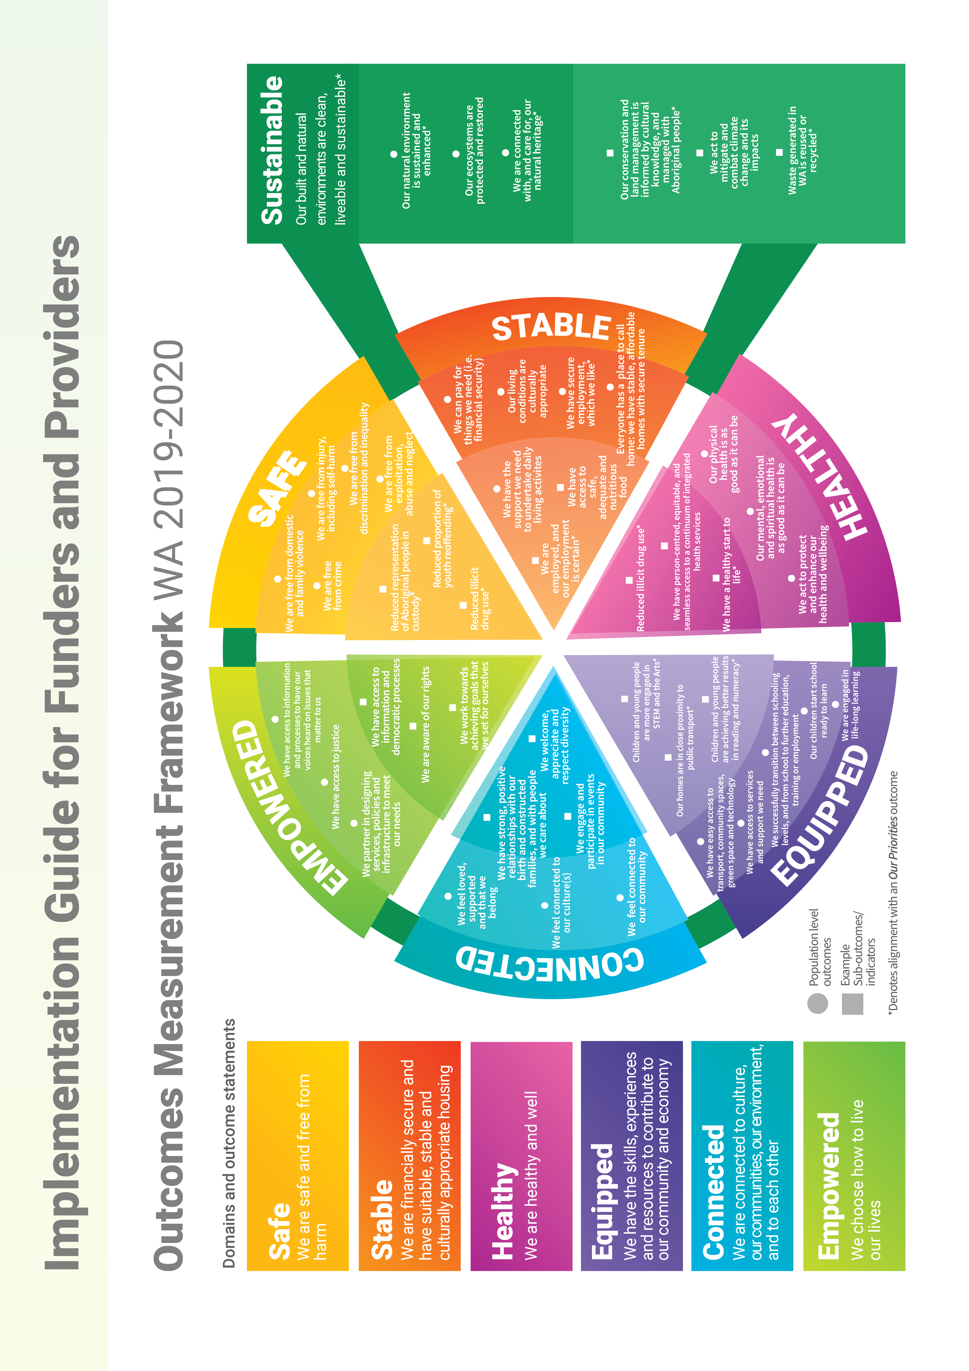
Introduction to the Framework
The Community Services WA Outcomes Measurement Framework is a hierarchy of population level outcomes and a bank of indicators, providing a common language for service delivery across government agencies and community services organisations.
Drawing extensively on work in other jurisdictions, it provides the architecture for a whole-of-government and a whole-of-sector approach. The intent of the Framework is to orient our attention to the outcome, rather than the output; and to the person, rather than to the program.
There is increasing recognition that shared outcomes are vital to drive a unified vision for the wellbeing of all Western Australians. The Framework was an election commitment.
Although there are several strategies, policies and targets across government that require a common language, there are significant differences in the way in which the language of outcomes are currently used across government and the community services sector.
This Framework provides the scaffolding to support the move to an outcomes focus in community service delivery. The Framework is not intended to add administrative burden to funders and providers, but to streamline reporting, as this shifts to a greater emphasis on outcomes focus over time.
The WA Outcomes Measurement Framework consists of:
- Illustrative framework – encompassing population-level outcomes in domains, with example sub-outcomes and indicators
- Extensive (though not exhaustive) draft sub outcomes and indicators bank (attached)
- Introduction and principles of the Framework

Overview of Implementation Guide
The Framework can be used in a procurement cycle for agencies, and in a strategic planning context for organisations, through aligning purchasing and programing to population level outcomes. This Guide provides high-level guidance and examples to demonstrate how:
- Program logic can be applied to funded services and programs
- The most relevant population-level outcomes from the Framework can be identified and how indicators and datasets may be used
Note, the draft sub-outcomes and indicator bank are still being finalised, but can be used in their current format to provide guidance to government agencies and the community services sector on integration of population level outcomes with service level outcomes.
Understanding the underpinning concepts: The logic model and theory of change
The Framework is based on a program logic model and the concept of theory of change. Program logic simply refers to the theory that underpins the flow or articulation of outcomes.
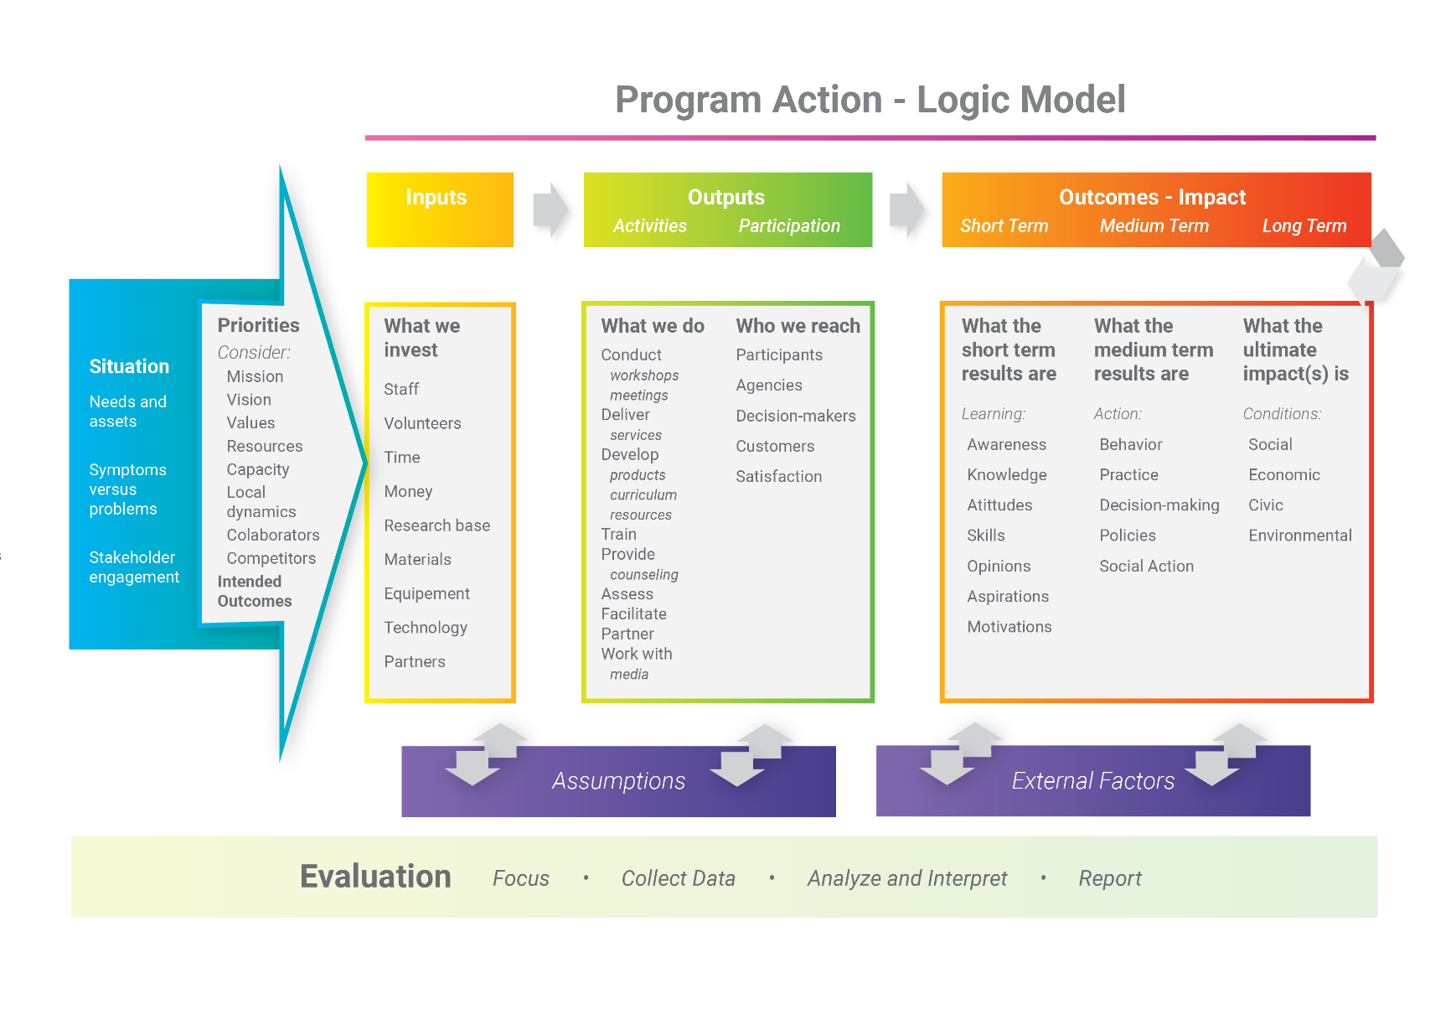
Sometimes ‘program logic’ and ‘theory of change’ are used interchangeably to mean the same thing. Sometimes ‘theory of change’ is used to describe more accurately the assumptions that underpin why and how all these things in the logic model link up, often described in ‘if-then’ statements.
For example, why is it that if we have these kinds of inputs (time, staff, etc) and we invest them in these kinds of ways (providing counselling or training), then we should achieve certain outputs (attendance, skills, satisfaction, etc)?
The answer to this question would be part of the theory of change for that logic model. The other pieces of that theory of change would be answers to the following questions:
- How does x kinds of outputs lead to changes in y outcomes?
- How does y kinds of learning outcomes (shorter-term) lead to z actions or behaviour shifts (medium-term outcomes or impact)?
Regardless of the way in which the terminologies are used, it is generally accepted that when we are talking about and measuring outcomes, that program logic or theory of change underpins it. It is important that, before using this guide, there is an understanding of essential elements of these.

- Using the Outcomes Measurement Framework generally
In its current form, the Framework can be used to align existing programs, strategies, frameworks and policies with a common language, which will influence future reviews.
The Framework can also be used as a starting point to develop new programs, strategies, policies with the common language contained within the Framework.
This Guide provides examples from both the perspective of funder and provider.
To use the Framework, it is important to understand the Organising Principles underpinning it. In summary these are,
- The Framework is indefinitely iterative and it will continue to be developed through implementation and review in a variety of different contexts.
- The Framework is loosely based on Maslow’s hierarchy of needs (Safe, Stable, Healthy, Equipped, Connected, Empowered). Sub-outcomes and indicators are inserted into the ‘earliest’ domain they can appropriately fit in.
- The Framework domains are intertwined. A person’s life consists of elements across every domain, highly dependent upon one another.
- The outcomes in this Framework are person-centred and population-level. At the population-level, this means that elements within the Framework will be the starting point or the end point, depending on the context or circumstance. There are examples of both system-level and program/service level outcomes developed in this guide to show this sequence.
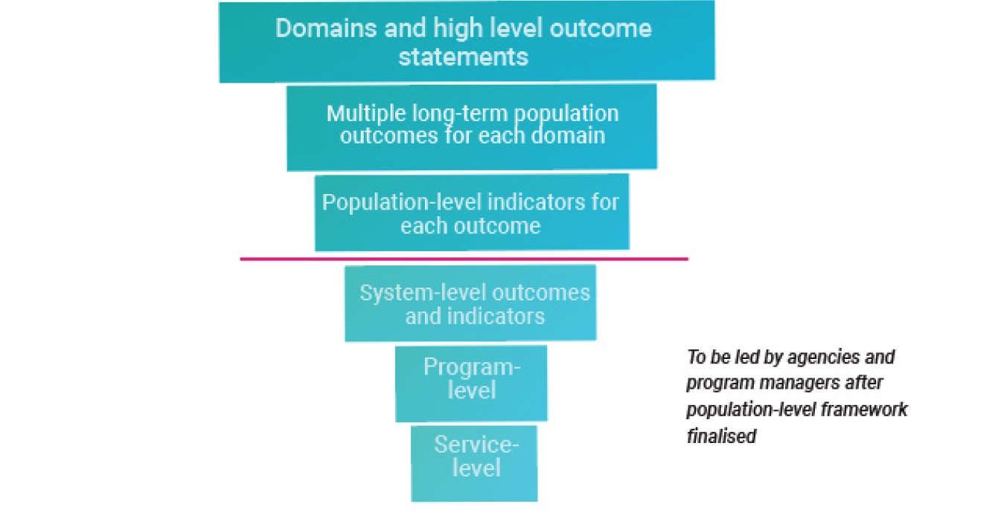
- If a sub-outcome can properly and appropriately fit under one of the other population-level outcomes rather than the domain-level outcome, that is where it will sit.
- Although a particular identity, experience or stage of life is sometimes referenced in the Framework, it is important to note that ‘we’ encompasses every identity, experience and stage of life.

With an understanding of outcomes, and the organising principles underpinning the Framework, you can use its contents in any way that is suitable given your particular context.
A shared Framework, co-developed across sectors is also imperative to inform evaluation and investment in community services. Conversely, evaluation and investment must be rigorous and targeted to ensure we have improved community outcomes.

- Using the Outcomes Measurement Framework as a funding agency
A government department/funding agency can map service or program level outcomes within a funding contract to population level outcomes within the Framework.
Engaging with the Outcomes Measurement Framework with an existing service
This example of the Department of Communities’ Family Support Network shows how program level indicators and outcomes can be mapped across different population level indicators and outcomes. This mapping has happened retrospectively for an existing service.
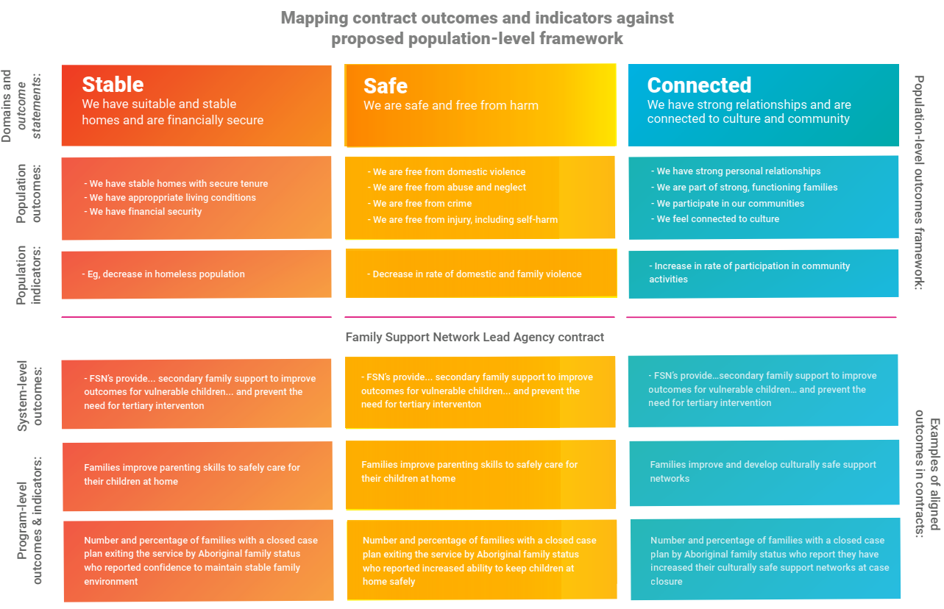

The table below also shows how existing service or program level indicators and outcomes can be mapped to the higher level population indicators and outcomes in the Framework.
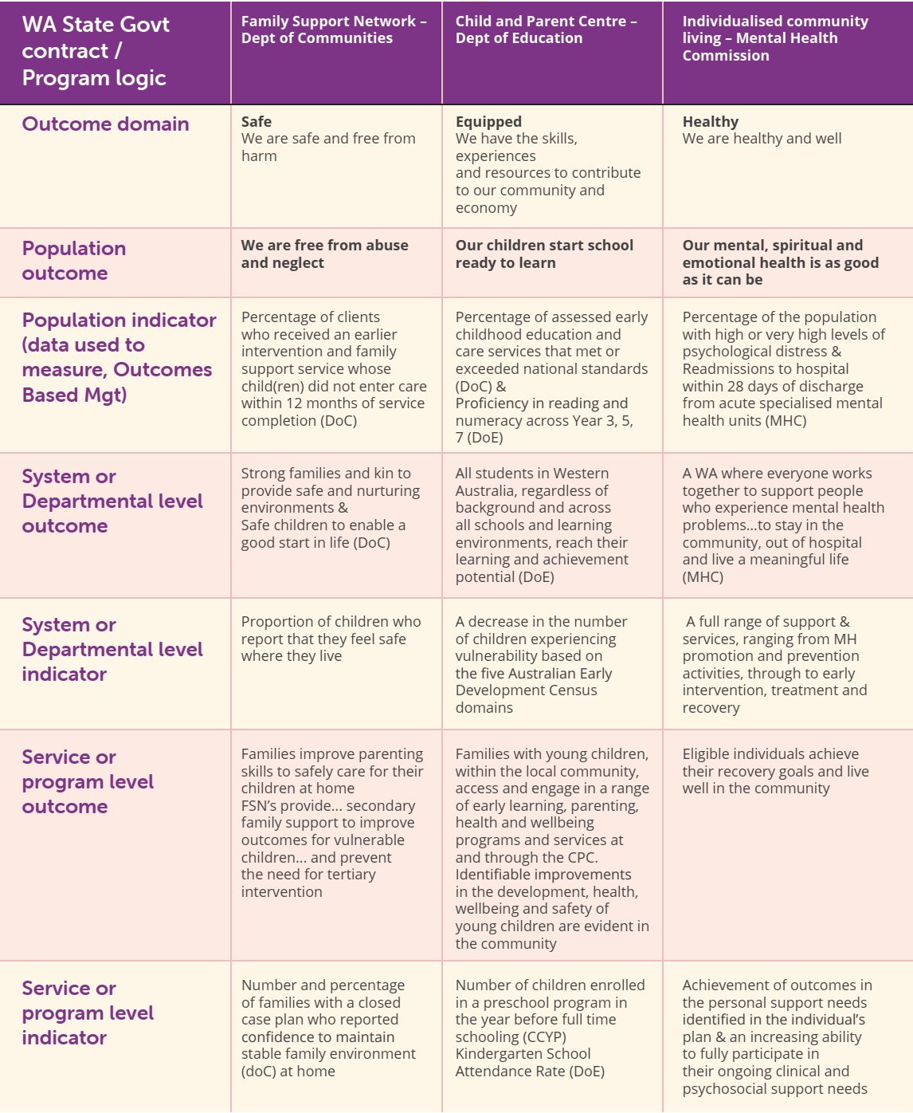
This example is presented simply, using only one outcome domain for each contract when in reality those contracts would reach across more than one outcome domain, and more than one population level outcome, like the Family Support Network above.
The indicators used in this linear example are from Treasury’s Outcomes Based Management lists. The already compiled bank of population indicators to choose from are attached to this guide.
Although this example is illustrative rather than exhaustive, it is designed to show that the Framework has applicability across a diverse range of agencies, services and programs.

Engaging with the Outcomes Measurement Framework in developing a new service
In the case of a new program to be procured in future, it will be possible to start with the Framework and its agreed-upon, co-designed language and outcomes in the first instance rather than map these retrospectively.
Articulation and alignment of outcomes – guidelines
- Consider the domains of the Framework, and which are most relevant to the service being developed/procured.
  - It is possible (and likely in some contexts) that all domains will be relevant. Try to keep it to a maximum of four.
- Explore the population level outcomes, and sub-outcomes, within the bank for each domain chosen.
  - Which of these are most relevant to the service being procured?
  - Which of these could be relevant with small changes?
  - What is missing from the Framework from your perspective? (This is to inform the ongoing development of the Framework).
  - Keep the number of chosen population-level outcomes (across all your relevant domains) to between 3 and 6 if possible.
- Consider the indicators and measures that are attached to your population-level outcome. These help you to understand the shape and understanding of what the outcomes mean.
  - Which of these are most relevant to the service being procured?
  - Which of these could be relevant with small changes?
- Putting these together (your chosen population-level outcomes, sub-outcomes, indicators and measures), you will have a sense whether they describe your intended service well or whether there is something missing.
- As much as possible, replicate the wording from the Framework to your context.
  - The population-level outcomes will ideally require no change to make sense in your context.
  - The sub-outcomes may require some small changes to make sense in your context.
  - You can write the unique program/service level outcomes that make sense in your context, but in developing these, use consistent words and meaning as much as possible, to retain fidelity to the Framework.
  - The indicators and measures may require edits in your context (see more below).
Considering measurement of outcomes
Although funders will ideally be negotiating service indicators and measures with the agencies providing them, it is important to have some initial thoughts about the data and measurement.
- Indicators and measures attached to your relevant population-level outcome.
  - Is the data required for the indicators/measures something that the community service organisation you are procuring will be able to collect? Will this be a challenging task?
  - Is there something you may be able to do to support collection of that information from a whole-of-government perspective?
  - Is someone else potentially already collecting this information, and you might be able to work with them?
- Data source
  - If there is a data source listed, do you have easy access to that information? If not, can you get it?
  - If there is no data source listed, where do you think information about those indicators/measures might exist? Could you get access to that information?
- WA Targets or goals
  - If there is a relevant WA target or goal, do you have any early ideas about how your procured service will contribute to them?
  - If there is no WA target or goal listed, will your service be ‘creating’ one? Or will it add value to create one? If so, think about the other departments and organisations (beyond the service deliverer) that you might need to engage in creating that target.
Considering reporting to outcomes
Finally, in creating the reporting structure for your procured service ensure:
- That the indicators/measures are the same as, or as consistent with the Framework, as possible.
- There has been an open and transparent conversation with the provider about how the data for those indicators/measures can be collected, and what role government can play in terms of being a data source (if any).
- There is a common understanding about how this contract is contributing to any broader state government targets or goals, and what goals exist for this particular contract (if any).
Getting this part right is particularly exciting – it means that the data that the provider contributes in their reports can be aggregated or ‘rolled up’ into the data the Department collects across services. This means we can really start to have a bigger picture understanding about the progress we are having as a community across service-level or population-level outcomes.

- Using the Outcomes Measurement Framework as a service provider
A service provider can map service or program level outcomes within an existing funding contract to the Framework’s population level outcomes in the same way a procurer of services might.
A service provider might also think about how they align their organisational strategic plan, or a specific project or program, outcomes to the Framework.
The example below maps Vinnies provision of community relief and resilience services to the population outcomes in the Framework, using program logic sequencing.
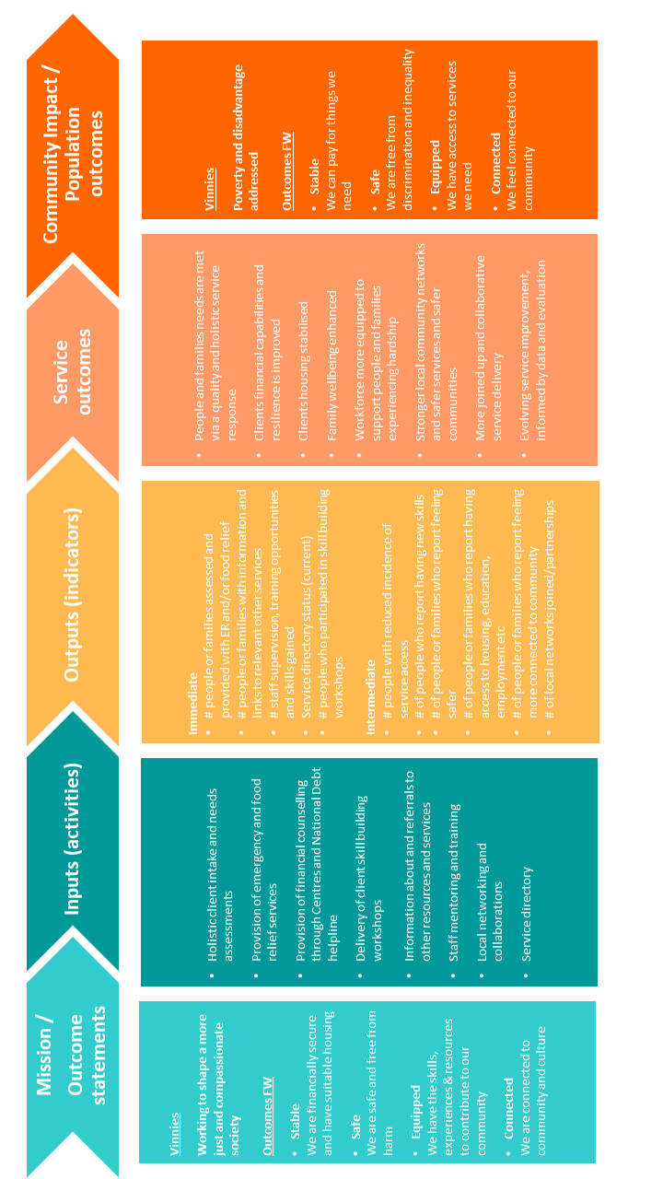

We know that the provision of the financial counselling and national debt helpline (activity) means that people receive financial counselling (output). Further, we know that if people receive financial counselling (output), then this contributes towards peoples and family’s needs being met (service outcome); and therefore we, as individuals, can pay for things we need (person-centred population-level outcome/impact from the Framework in the Stable domain).
We also need to consider the role of evidence and data in informing a theory of change. However, this is beyond the scope of this guide.

Guidance for engaging with the Framework in terms of strategy for a service provider
As described above, this could be either in developing a logic model to respond to a request for tender, or in looking at developing organisational or programmatic strategy outside of a procurement process.
Articulation and alignment of outcomes
- Consider the domains of the Framework, and which are most relevant to the service or program being developed or delivered.
  - It is possible (and likely in some contexts) that all domains will be relevant. Try to keep it to a maximum of four.
- Explore the population level outcomes, and sub-outcomes, within the Bank for each domain chosen.
  - Which of these are most relevant to the program you are developing or delivering?
  - Which of these could be relevant with small changes?
  - What is missing from the Framework from your perspective? (This is to inform the ongoing development of the Framework).
  - Keep the number of relevant population-level outcomes (across all your relevant domains) to between 3 and 6 if possible.
- Consider the indicators and measures that are attached to your population-level outcome. These help you to understand the shape and understanding of what the outcomes mean.
  - Which of these are most relevant to your service being developed or delivered?
  - Which of these could be relevant with small changes?
- Putting these together (your chosen population-level outcomes, sub-outcomes, indicators and measures), you will have a sense of whether these describe your intended program/service/organisation well, and what is missing.
- As much as possible, replicate the wording from the Framework to your context.
  - The population-level outcomes will ideally require no change to make sense in your context.
  - The sub-outcomes may require some small changes to make sense in your context.
  - You can write the unique program/service level outcomes that make sense in your context, but in developing these, use consistent words and meaning as much as possible, to retain fidelity to the Framework.
  - The indicators and measures may require edits in your context (see more below).

Considering measurement of outcomes
Although we touched on indicators/measures, most of the above steps are about articulation of outcomes. We also need to consider the collection of data and measurement of those outcomes.
- Indicators and measures attached to your relevant population-level outcome
  - Is the data required for the indicators/measures something that you currently collect, or will be able to collect? Will this be a challenging task?
  - Is someone else potentially already collecting this information, and you might be able to work with them?
- Data source.
  - If there is a data source listed, will it be possible for you to get access to that information?
  - If there is no data source listed, where do you think information about those indicators/measures might exist? Could you get access to that information?
- WA Targets or Goals
  - If there is a WA target or goal, do you have any early ideas about how your program/service will contribute to them?
  - If there is no WA target or goal listed, are there other outcomes hierarchies that exist nationally or internationally that your program/service may be contributing to? (e.g. Sustainable Development Goals). This alignment with other relevant frameworks can be really useful from the perspective of future investors/funders for your program/service.
Other tips
- Talk to people about your understanding of the outcomes, indicators and measures, and get their perspectives on what you are thinking. The Framework is intended, after all, to provide the architecture for a common language, common understanding across departments and sectors. We only get there through conversation, creating shared understanding, and having our own perspectives and assumptions challenged.
- Make sure you use your learning from undertaking this process to inform the ongoing development and refinement of the Framework.

For more guidance and support
Insert people to speak to/places to go here
- Department of Finance? FACS unit, or dedicated individual?
- WACOSS/Impact Seed/other implementation workshops?

